39.9: a) photon
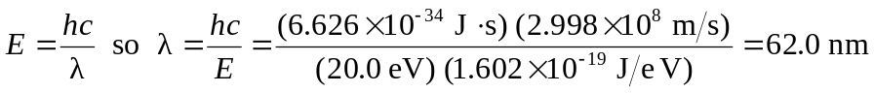
electron
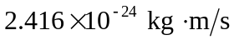
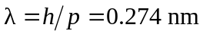
b) photon 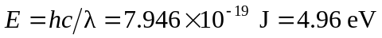
electron
c) You should use a probe of wavelength approximately 250 nm. An electron with
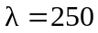nm has much less energy than a photon with nm, so is less likely to damage the
molecule.

